KAMPALA JUNIOR ACADEMY
HOLIDAY WORK SET TWO TERM I 2020
LITERACY II
PRIMARY ONE

My name is _________________________________________________
School _____________________________________________________

1. Fill in the missing letters.
(a) d__stbin (b) bl__ckboard (c) d__ster

2. Name these things found on your way to school.

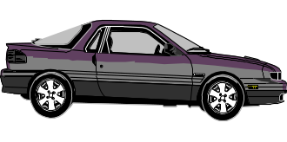 | 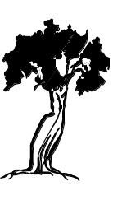 | 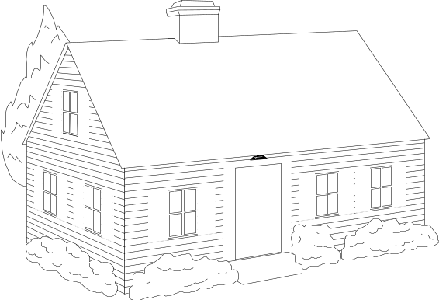

3. Name any two people found at school.
(a) _____________________ (b) ______________________

4. Circle the school symbols.
Pencil, flag, book, uniform, pen, signpost

5. Tick the activities of pupils at school. √
Reading Fighting Driving
Smoking Writing Sweeping
6. Draw these things in our home.
bed | spoon | chair

7. Match people to their work.
teacher prepares food.
doctor teaches pupils in a school.
driver treats the sick people.
cook controls a car or lorry.

8. Use Correct or Wrong
(a) A dog is a wild animal. ________________
(b) An elephant lives in the bush. ________________
(c) A young cat is a kitten. __________________
(d) Wind helps us to fly kites. ___________________

9. Write the homes of the following.
(a) man _______________ sty
(b) bird _______________ house
(c) pig ________________ nest
10. Read and answer the questions.
Peter: Hullo Sarah, where are you going?
Sarah: I am going to school to learn.
Peter: Who teaches you English?
Sarah: Teacher Tumusiime teaches us.
Peter: Oh, She is a good teacher.
Questions:
- How many people are talking?
____________________________________________________
- Who is going to school?
____________________________________________________
- Name the people who are talking.
- _____________________ (ii) ___________________
- Who teaches Sarah English?
___________________________________________________

11. Draw and name the parts of the body we use for;
(a) walking (c) hearing

(b) smelling (d) seeing

(eye leg ear nose)
12. Circle the wild animals only.
cow snake goat elephant tiger

13. Name the parts of a house.
a. ________________
a b. ________________
b c. ________________
d c d. ________________

14. Tick √ the members of an extended family.
father auntie daughter
uncle mother niece

15. Draw these building materials.
Stones | grass | nails

*** END ***

